Classification Of Arrhythmia By Using Deep Learning With 2-D ECG Spectral Image Representation

**A PROJECT REPORT**

**Submitted By**

**M.NAVANEETHA KRISNAN**

**R.SETHU RAM**

**T.VIGNESHWARAN**

**P.ARUN MANI**

**in partial fulfilment for the award of the degree of**

**Bachelor of Engineering IN**

**COMPUTER SCIENCE ENGINEERING**

**DHANALAKSHMI SRINIVASAN COLLEGE OF ENGINEERING**

# ANNA UNIVERSITY: CHENNAI 600 025

ANNA UNIVERSITY : CHENNAI 600 025

# BONAFIDE CERTIFICATE

Certified that this project report “**Classification Of Arrhythmia By Using Deep Learning With 2-D ECG Spectral Image Representation**” is the bonafide work of”M.NAVANEETHA KRISHNAN,VIGNESHAWARN,SETHU RAM,ARUN MANI ” who carried out the project work under my supervision.

SIGNATURE

HEAD OF THE DEPARTMENT

## 

## TABLE OF CONTENTS

**CHAPTER NO TITLE PAGE NO.**

1. INTRODUCTION 5
   1. Project Overview
   2. Purpose
2. LITERATURE SURVEY 6
   1. Existing problem
   2. References
   3. Problem Statement Definition

## IDEATION & PROPOSED SOLUTION 9

* 1. Empathy Map Canvas
  2. ideation & Brainstorming
  3. Proposed Solution
  4. Problem Solution fit

## REQUIREMENT ANALYSIS 14

* 1. Functional requirement
  2. Non-Functional requirements

## PROJECT DESIGN 16

* 1. Data Flow Diagrams
  2. Solution & Technical Architecture
  3. User Stories

## PROJECT PLANNING & SCHEDULING 17

* 1. Sprint Planning & Estimation
  2. Sprint Delivery Schedule
  3. Reports from JIRA

## TABLE OF CONTENTS

**CHAPTER NO. TITLE PAGE NO.**

## CODING & SOLUTIONING 19

* 1. Feature1
  2. Feature 2
  3. Database Schema

## TESTING 25

* 1. Test Cases
  2. User Acceptance Testing

## RESULTS 26

* 1. Performance Metrics

## ADVANTAGES & DISADVANTAGES 28

* 1. Advantages
  2. Disadvantages

## CONCLUSION 29

1. **FUTURE SCOPE 29**

## APPENDIX 30

Source Code

GitHub & Project Demo Lin

***Classiﬁcation of Arrhythmia by Using Deep Learning with 2-D ECG Spectral Image Representation***

# INTRODUCTION:

## PROJECT OVERVIEW:

According to the World Health Organization (WHO), cardiovascular diseases (CVDs) are the number one cause of death today. Over

17.7 million people died from CVDs in the year 2017 all over the world which is about 31% of all deaths, and over 75% of these deaths occur in low and middle-income countries. Arrhythmia is a representative type of CVD that refers to any irregular change from the normal heart rhythms. There are several types of arrhythmia including atrial fibrillation, premature contraction, ventricular fibrillation, and tachycardia. Although a single arrhythmia heartbeat may not have a serious impact on life, continuous arrhythmia beats can result in fatal circumstances. In this project, we build an effective electrocardiogram (ECG) arrhythmia classification method using a convolutional neural network (CNN), in which we classify ECG into seven categories, one being normal and the other six being different types of arrhythmia using deep two-dimensional CNN with grayscale ECG images. We are creating a web application where the user selects the image which is to be classified. The image is fed into the model that is trained and the cited class will be displayed on the webpage.

## PURPOSE*:*

In the past few decades, Deep Learning has proved to be a

compelling tool because of its ability to handle large amounts of data. The interest to use hidden layers has surpassed traditional techniques, especially in pattern recognition. One of the most popular deep neural networks is

Convolution al Neural Networks.

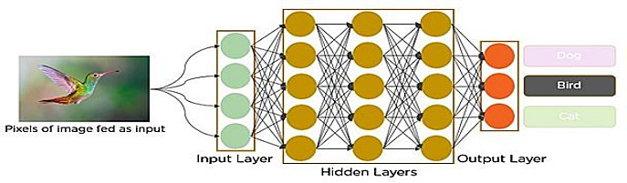

In deep learning, a convolution al neural network (CNN/ConvNet) is a class of deep neural networks, most commonly applied to analyze visual imagery. Now when we think of a neural network we think about matrix multiplications but that is not the case with ConvNet. It uses a special technique called Convolution. Now in mathematics convolution is a mathematical operation on two functions that produces a third function that expresses how the shape of one is modified by the other.

# LITERATURE SURVEY :

## EXISTING PROBLEM :

Cardiovascular diseases (CVDs) are the number one cause of death today. Over 17.7 million people died from CVDs in the year 2017 all over the world which is about 31% of all deaths, and over 75% of these deaths occur in low and middle-income countries. Arrhythmia is a representative type of CVD that refers to any irregular change from the normal heart rhythms. There are several types of arrhythmia including atrial fibrillation, premature contraction, ventricular fibrillation, and tachycardia.

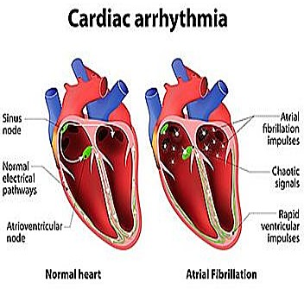

* 1. ***REFERENCES:***
     + Amin Ullah Syed Muhammad Anwar, Muhammad Bilal, and Raja Majid Mehmood (2020)
     + Bazi, Haikel AlHichri, Naif Alajlan, Farid Melgani, Ronald R Yager (2022)
     + Faezeh Nejati Hatamian, Nishant Ravikumar, Sulaiman Vesal(2020)
     + Fatma Murat, Ozal Yildirim, Muhammed Talo, Ulas Baran Baloglu, Yakup Demir, U Rajendra Acharya (2020)
     + Han Lia, Xinpei Wanga, Changchun Liua, Peng Lib Yu Jiaoa (2021)
     + Jagdeep Rahul Lakhan Devi Sharma (2022)
     + Kurniawan, I Ketut Eddy Purnama, Mpu Hambyah Syah Bagaskara Aji (2021)
     + Ozal Yildirima, MuhammedTaloa, BetulAybUlas BaranBalogluc, GalipAydinbU, RajendraAcharya (2020)
     + Rashidah Funke Olanrewaju, S. Noorjannah Ibrahim, Ani Liza Asnawi, Hunain Altaf (2021)
     + Rui Hu, Jie Chen, Li Zhou (2022)

## PROBLEM STATEMENT DEFINITION:

More than four million of people, mostly over age sixty, are suffering from various kinds of arrhythmias that cause discomfort or even sudden cardiac death (SCD).Fast and accurate classification of large set of Electrocardiogram (ECG) beats containing both normal and arrhythmic categories is still a challenging task for the state-of-the art classification algorithms. The ECG signals can capture the heart’s rhythmic irregularities, commonly known as arrhythmias. A careful study of ECG signals is crucial for precise diagnoses of patients’ acute and chronic heart conditions. A two- dimensional (2-D) convolutional neural network (CNN) model is helpful for the classification of ECG signals into eight classes.The one-dimensional ECG time series signals are transformed into 2-D spectrograms through short-time Fourier transform. The 2-D CNN model consisting of four convolutional layers and four pooling layers is designed for extracting robust features from the input spectrograms. Using Deep Learning CNN we can enhance the accuracy of diagnosis algorithms in the fusion of medicine and modern machine learning technologies. The proposed CNN-based classification algorithm, using 2-D images, can classify eight kinds of arrhythmia.

# IDEATION & PROPOSED SOLUTION :

## EMPATHY MAP CANVAS :

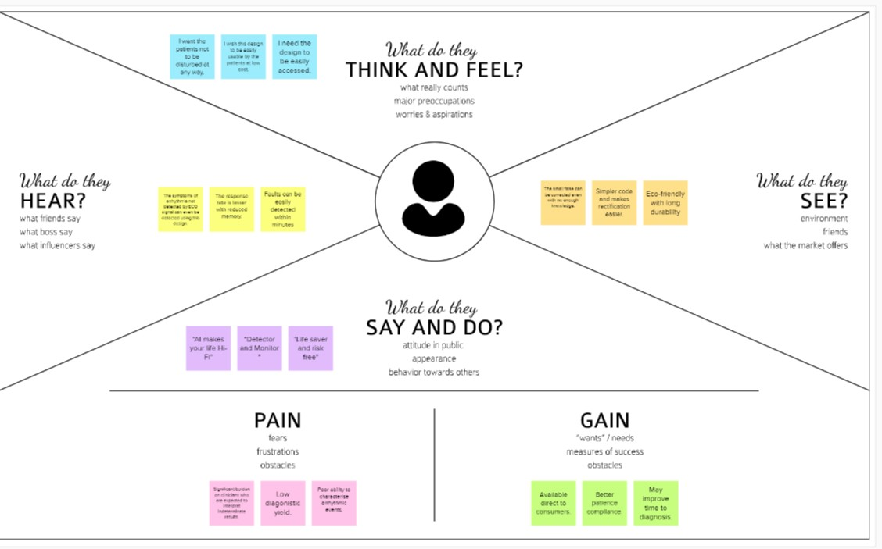

* 1. **IDEATION & BRAINSTORMING:**



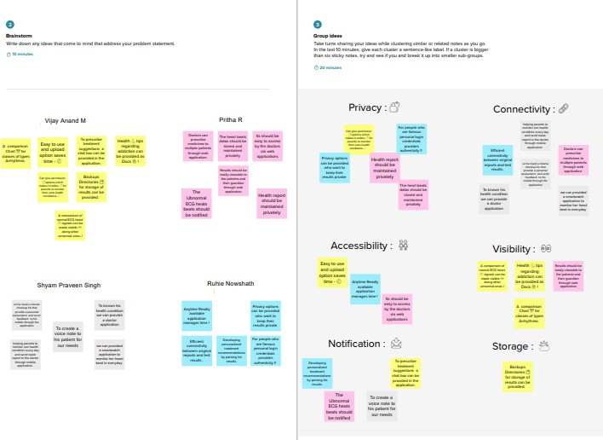

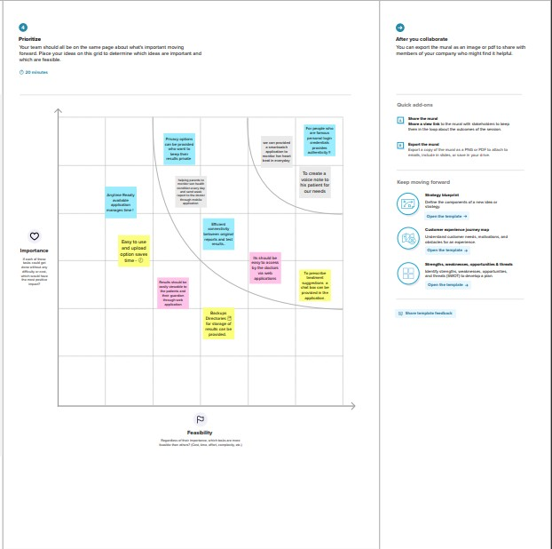

## PROPOSED SOLUTION:

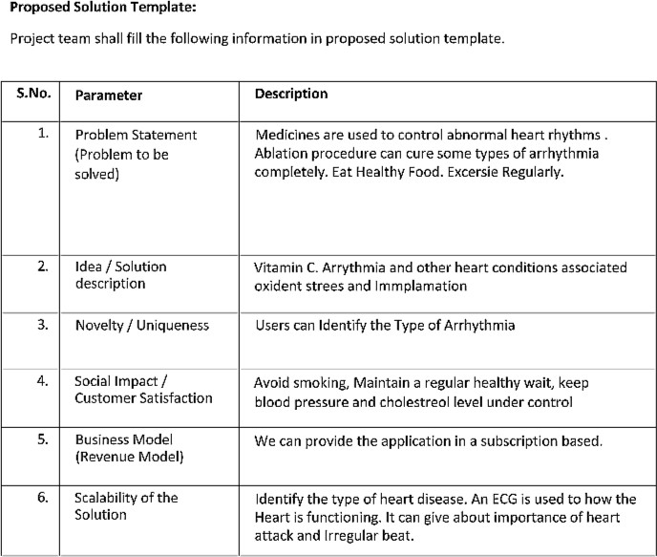

* 1. **PROBLEM SOLUTION FIT :**

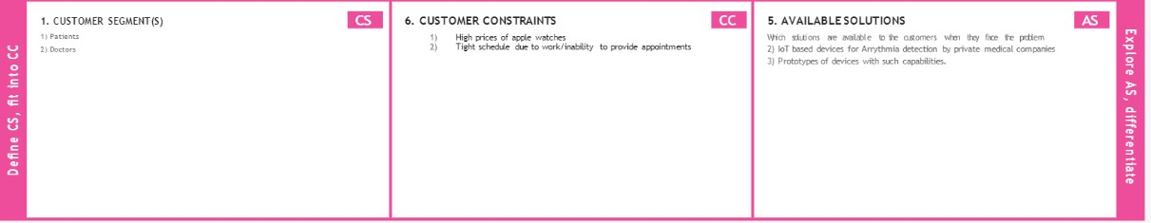

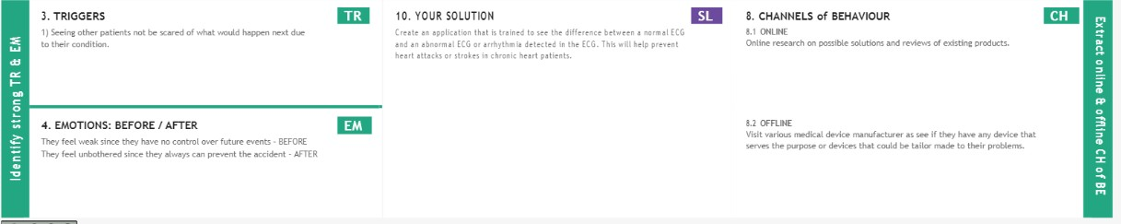

# REQUIREMENT ANALYSIS:

* 1. **FUNCTIONAL *REQUIREMENT:***

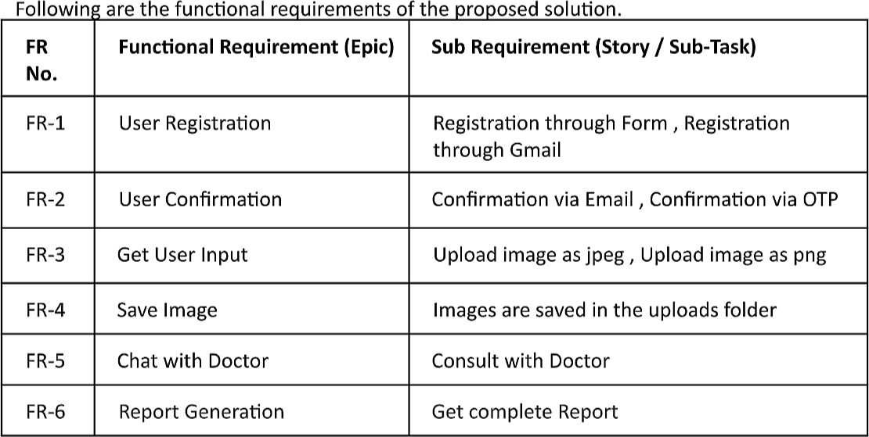

* 1. ***NON-FUNCTIONAL REQUIREMENTS :***

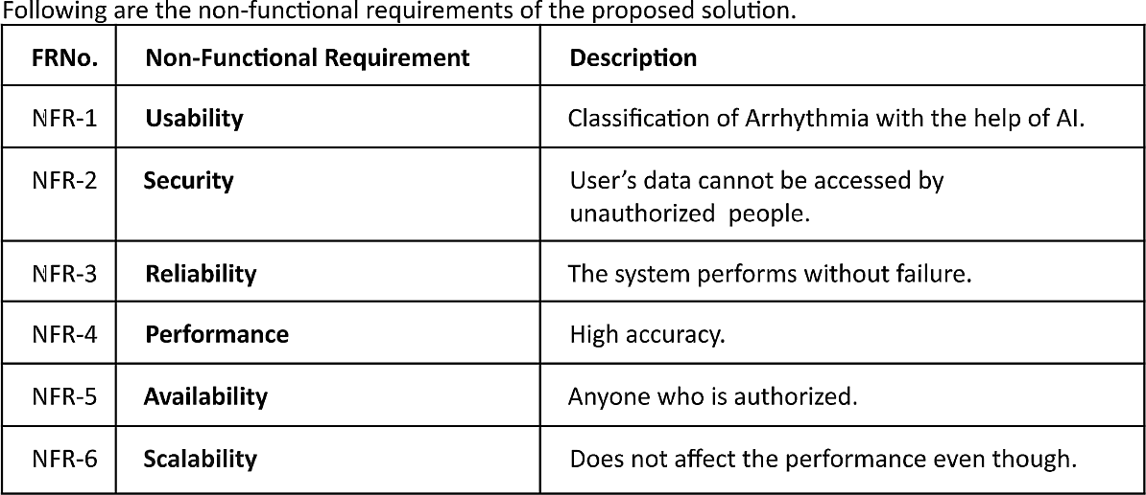

1. **PROJECT DESIGN:**
   1. ***DATA FLOW DIAGRAMS:***

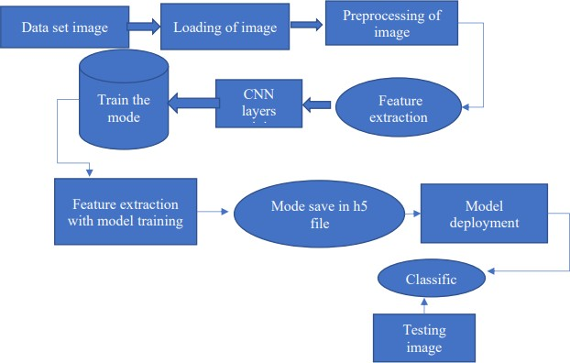

## SOLUTION & TECHNICAL ARCHITECTURE :

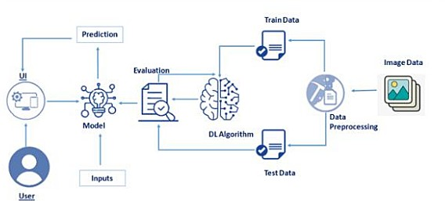

* 1. **USER STORIES :**

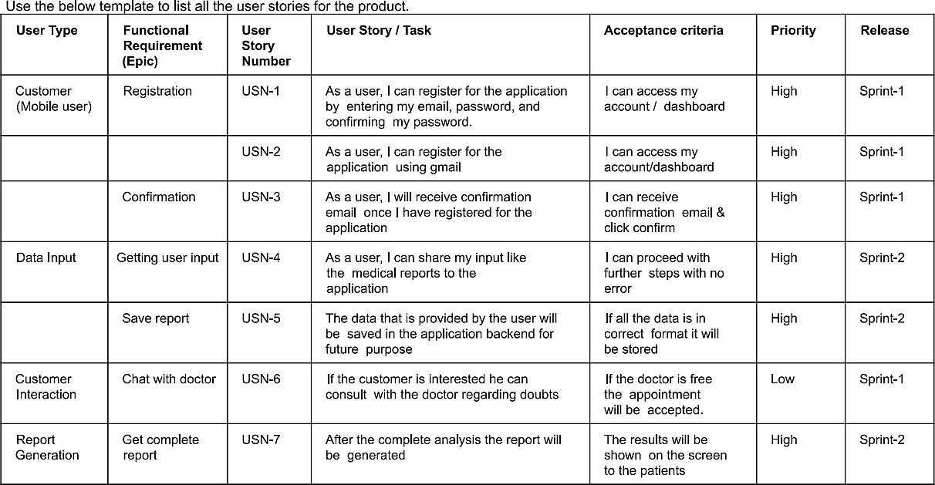

## PROJECT PLANNING & SCHEDULING:

* 1. ***SPRINT PLANNING & ESTIMATION:***

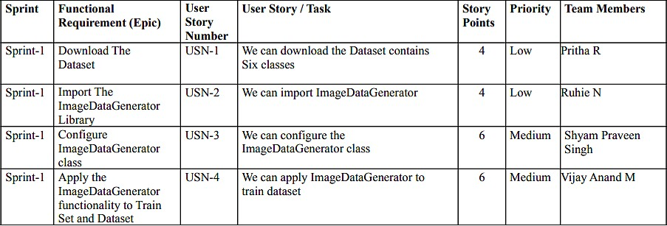

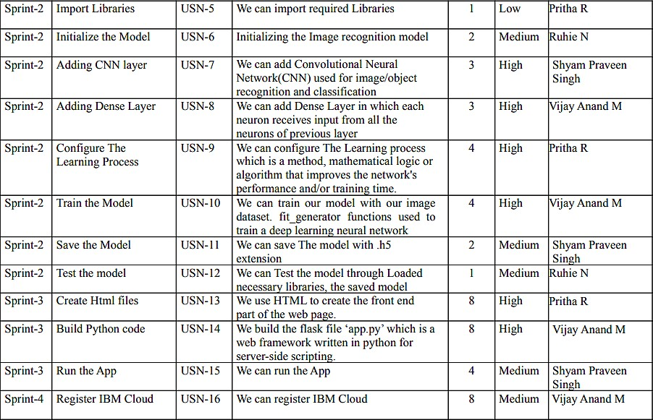



* 1. ***SPRINT DELIVERY SCHEDULE:***

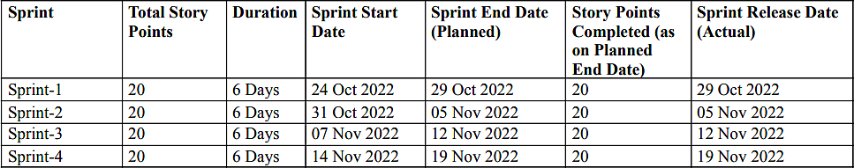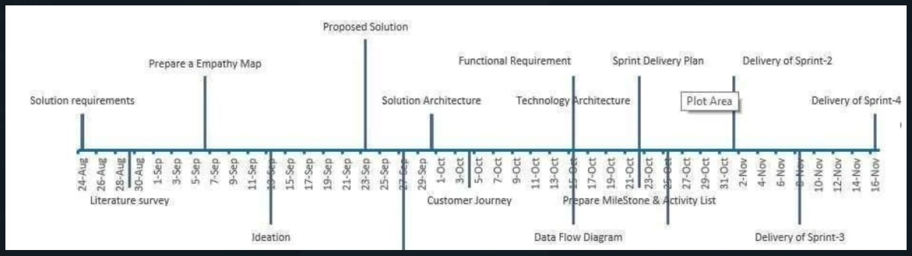

* 1. ***REPORTS FROM JIRA:***



## CODING & SOLUTIONING:

* 1. **FEATURE 1:**

**7.1.1 App.py**

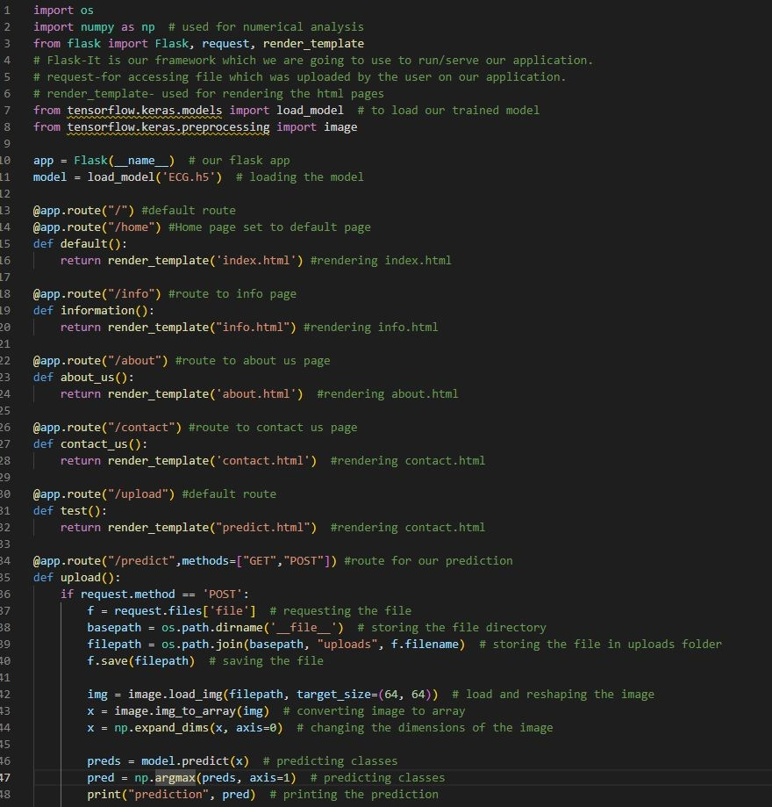

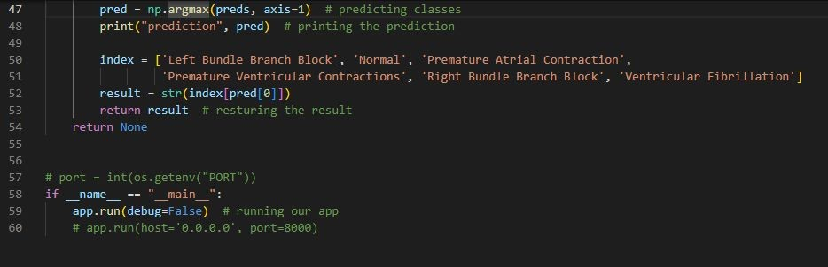

## FEATURE 2:

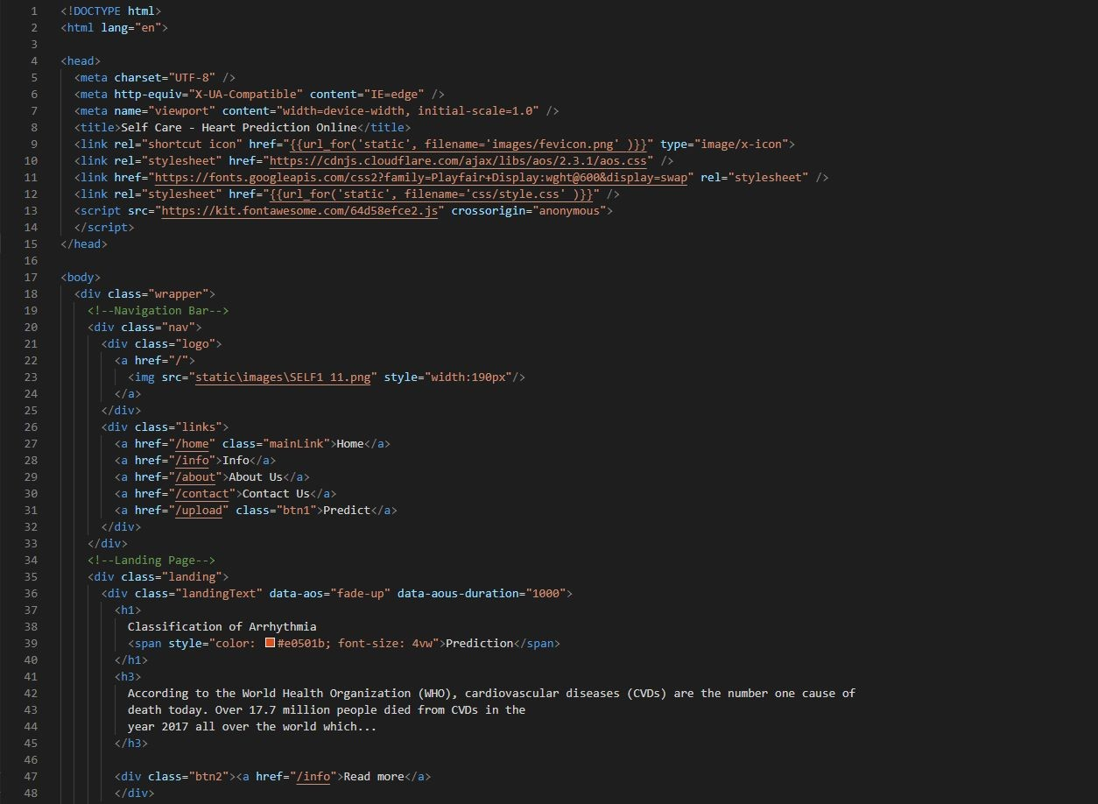**7.2.1Homepage.html**

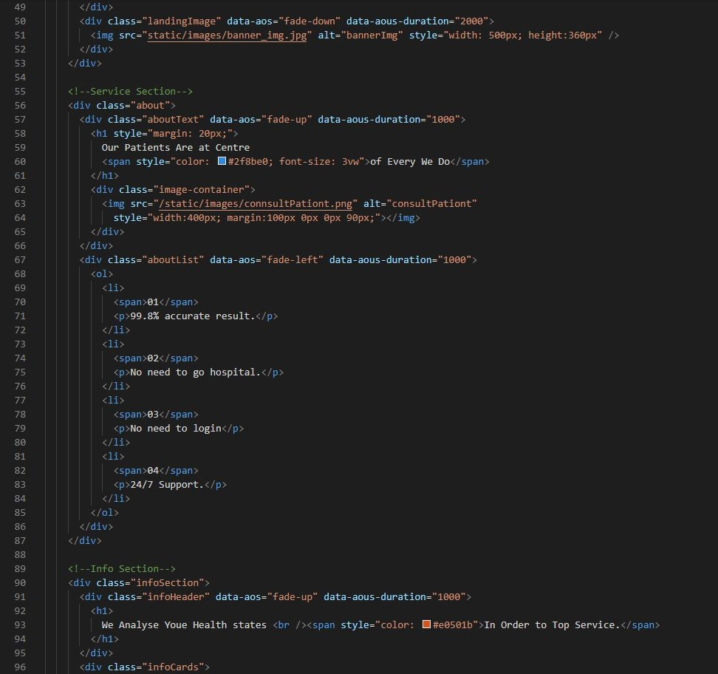

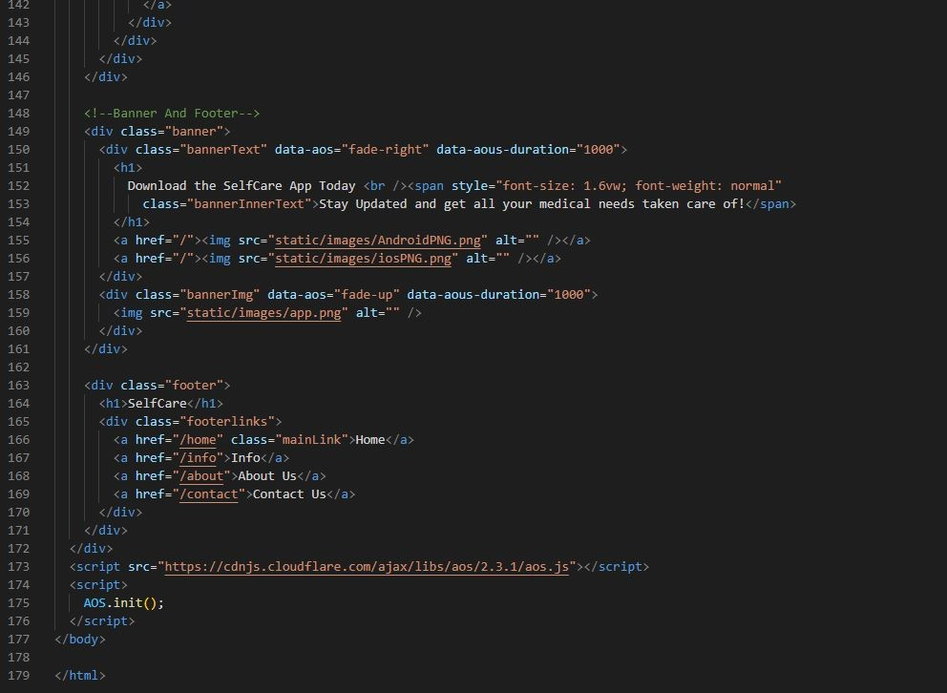

## about.html

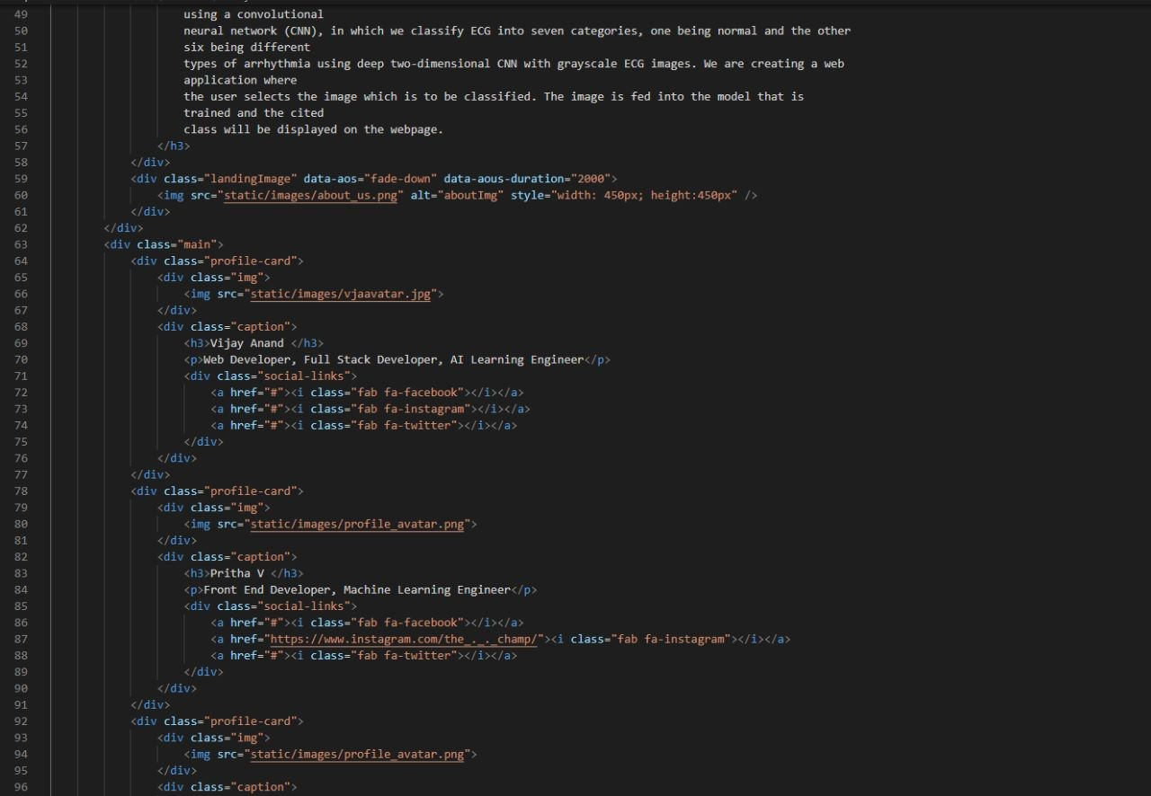

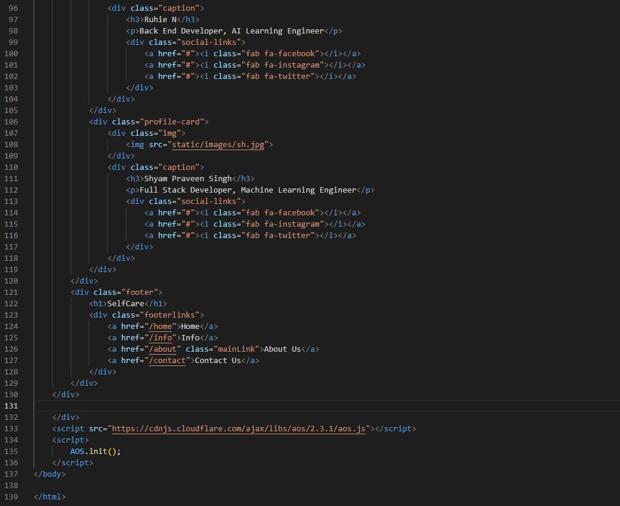

* + 1. 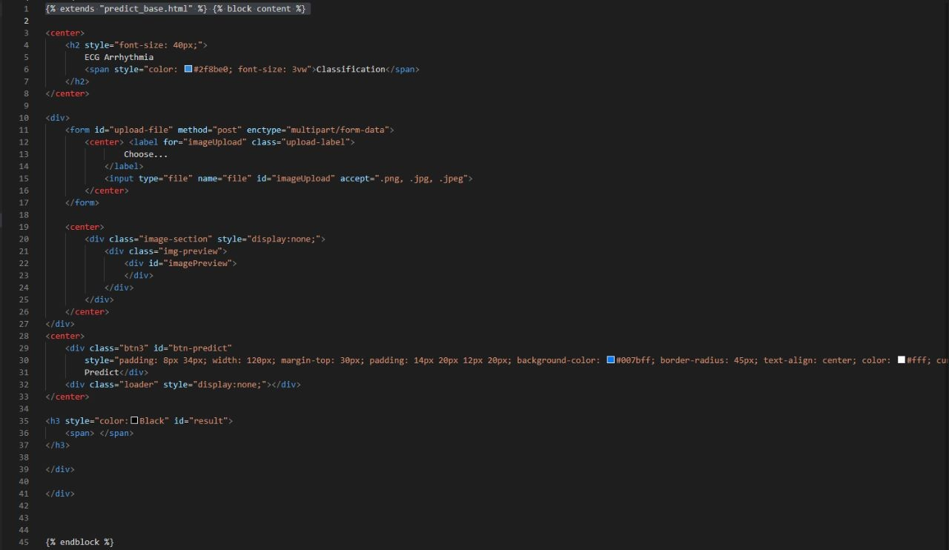**Predict.html**

# TESTING:

## TEST CASES:

* 1. **USER ACCEPTANCE TESTING :**

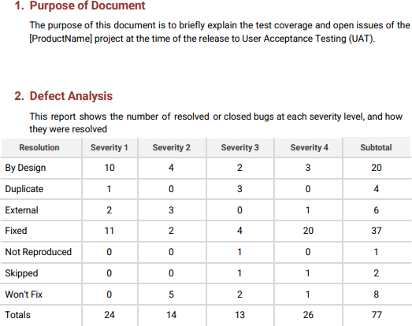

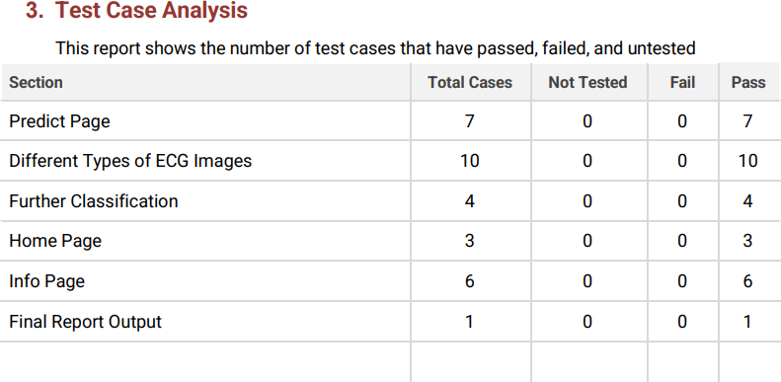

## RESULTS:

* 1. **PERFORMANCE METRICS** :

The two signiﬁcant optimization parameters in the proposed 2-D CNN model are the learning rate and the batch size of the data used. To improve the performance, these two optimization parameters must be selected carefully to obtain the best accuracy in the automatic classiﬁcation of arrhythmia using the ECG signals. The proposed model was evaluated in different experiments with various values of learning parameters. For a smaller value of the learning rate (i.e., less than 0.0005), the speed of the convergence was very slow. However, when the value of the learning rate was large (i.e., greater than0.001), the speed of convergence improved. At the same time, asymmetrical changes were observed in the accuracy rate. Henceforth, we selected an optimum value of 0.001 for the learning rate, as this value can attain better accuracy for the proposed model (i.e., optimum value).

***Batch sizes and average accuracy for a learning rate of 0.001.***

|  |  |  |
| --- | --- | --- |
| Learning Rate | Batch Size | Average Accuracy |
| 0.001 | 2800 | 99.11 |
| 0.001 | 2000 | 98.96 |
| 0.001 | 1000 | 99.00 |
| 0.001 | 500 | 98.95 |
| 0.001 | 100 | 98.93 |

## Learning rate and average accuracy for a batch size of 2800.

|  |  |  |
| --- | --- | --- |
| Batch Size | Learning Rate | Average Accuracy |
| 2800 | 0.001 | 99.11 |
| 2000 | 0.001 | 98.96 |
| 1000 | 0.001 | 99.00 |
| 500 | 0.001 | 98.95 |
| 100 | 0.001 | 98.93 |

We compared the proposed CNN-based model with recent techniques for the automatic classiﬁcation of arrhythmia where the algorithm achieved 97.88% average sensitivity, 99.61% speciﬁcity, 99.11% average accuracy, and 98.59% positive predictive value (precision). These values indicate improved performance when compared with recent methods using of 1-D and 2-D CNNs, given the same arrhythmia classiﬁcation. The results also show that the proposed CNN algorithm has better results in terms of accuracy with both the augmented and without augmented data.

The proposed model has attained the highest sensitivity among all the compared CNN algorithms.It is pertinent to note that detecting these cardiac arrhythmias is a labor intensive task, where a clinical expert needs to carefully observe recordings that can go for up to hours. With such automated methods,the artiﬁcially intelligent system could augment the performance of clinical experts by detecting these patterns and directing the observer to look more closely at regions of more signiﬁcance. This would ultimately improve the clinical diagnosis and treatment of some of the major CVDs.

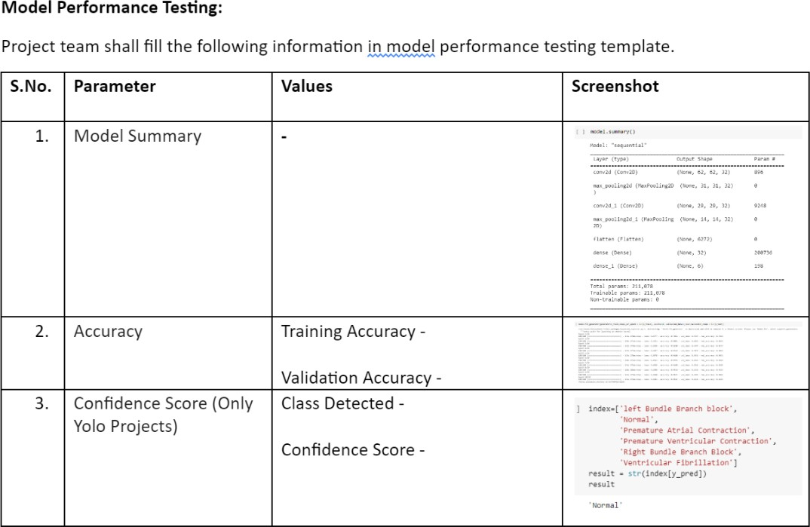

# ADVANTAGES & DISADVANTAGES:

## ADVANTAGES :

* We classify ECG into seven categories, one being normal and the other six being different types of arrhythmia using deep two-dimensional CNN with grayscale ECG images.
* To overcome the challenge for the visual and physical explanation of the ECG signal, computer-aided study has been developed to automatically identify such signals automatically.
* A careful study of ECG signals is crucial for precise diagnoses of patients' acute and chronic heart conditions.
* The performance is significant in other indices as well, including sensitivity and specificity, which indicates the success of the proposed method.
* A simple User Interface for the users to classify their ECG report.
* Great User Experience to make is simple and easy to use for users and patients while accessing the website

## DISADVANTAGES:

* + - The efﬁciency and accuracy of could be negatively affected by the increasing size of data.
    - The techniques presented been applied to smaller datasets.
    - For the purpose of generalization, the performance should betested on larger datasets.
    - Most methods have been tested on only a few types of arrhythmia and must be evaluated on all major types of arrhythmia.
* It should be noted that the performance of methods developed for 1-D ECG signals can be further improved.

## CONCLUSION:

In this study, we proposed a 2-D CNN-based classiﬁcation model for automatic classiﬁcationof cardiac arrhythmias using ECG signals. An accurate taxonomy of ECG signals is extremely helpful in the prevention and diagnosis of heart diseases. Deep CNN has proven useful in enhancing the accuracy of diagnosis algorithms in the fusion of medicine and modern machine learning technologies.The proposed CNN-based classiﬁcation algorithm, using 2-D images, can classify seven kinds of arrhythmia. These results indicate that the prediction and classiﬁcation of arrhythmia with 2-D ECG representation as spectrograms and the CNN model is a reliable operative technique in the diagnosis of heart diseases.The proposed scheme can help experts diagnose heart diseases by referring to the automated classiﬁcation of ECG signals.

The present research uses only a single-lead ECG signal. The effect of multiple lead ECG data to further improve experimental cases will be studied in future work.

## FUTURE SCOPE :

For future work, it would be interesting to explore the use of optimization techniques to find a feasible design and solution. The limitation of our study is that we have yet to apply any optimization techniques to optimize the model parameters and we believe that with the implementation of the optimization, it will be able to further elevate the performance of the proposed solution to the next level.

These are the further improvements that can be made in the future:-

* Further classification for upto 8-10 different types of arrhythmia will be possible.
* Improved accuracy for bigger data size.
* The techniques presented been applied to smaller datasets can be made much faster and efficient.
* Improved UI & UX for the users.

# APPENDIX:

**SOURCE CODE LINK: https://github.com/IBM-EPBL/IBM-Project-51619-1660981043**

**PROJECT DEMO LINK: https://youtu.be/cAQOxbVSRvw**